Employee System Database  
User Manual

CPSC-488 Spring 2023

04/24/2023

Maya Smallwood [mns1013@sru.edu](mailto:mns1013@sru.edu)

Paul Schlabach [pms1006@sru.edu](mailto:pms1006@sru.edu)

Bradon Walters [bdw1006@sru.edu](mailto:bndw1006@sru.edu)

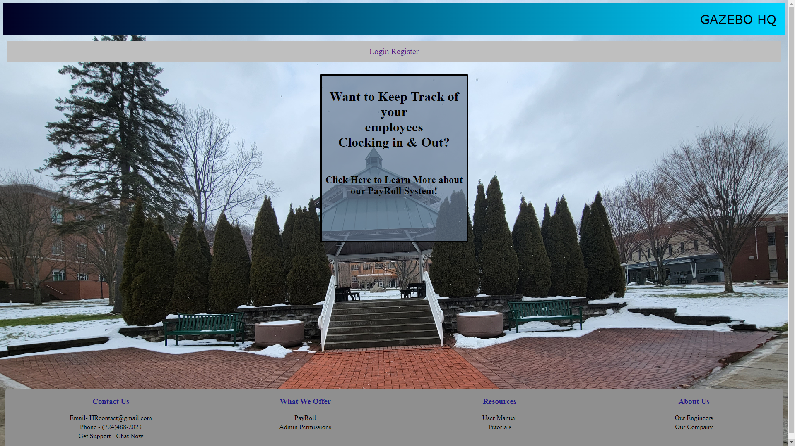

## Figure 1. Landing Page

* Upon running the application, the user will see this landing page
* They will have the option to Login or Register a new account

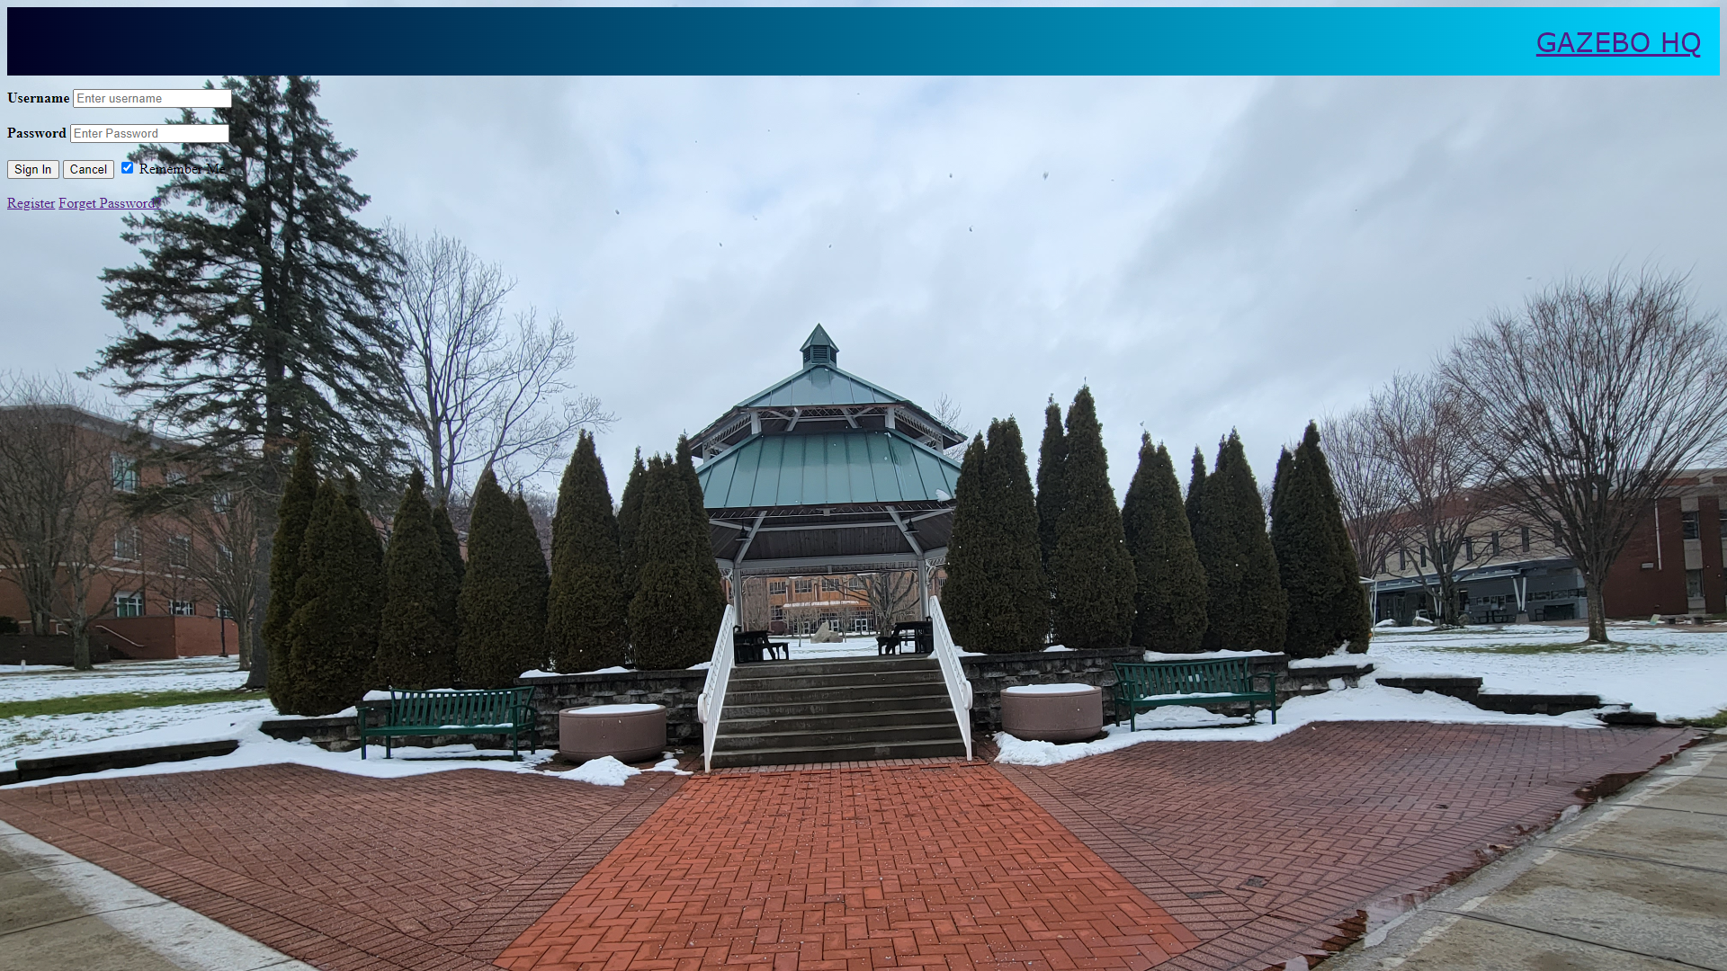

## Figure 2. Login Page

* Once on the login page, users will sign in using their username and password associated with their registered account.
* If you have imported the **data.sql** file you will have to select “Forgot Password?” to create a password. To login in with one of the import user’s username.
* If you do not have a account you can also reach the Register page from here by selecting “Register”.

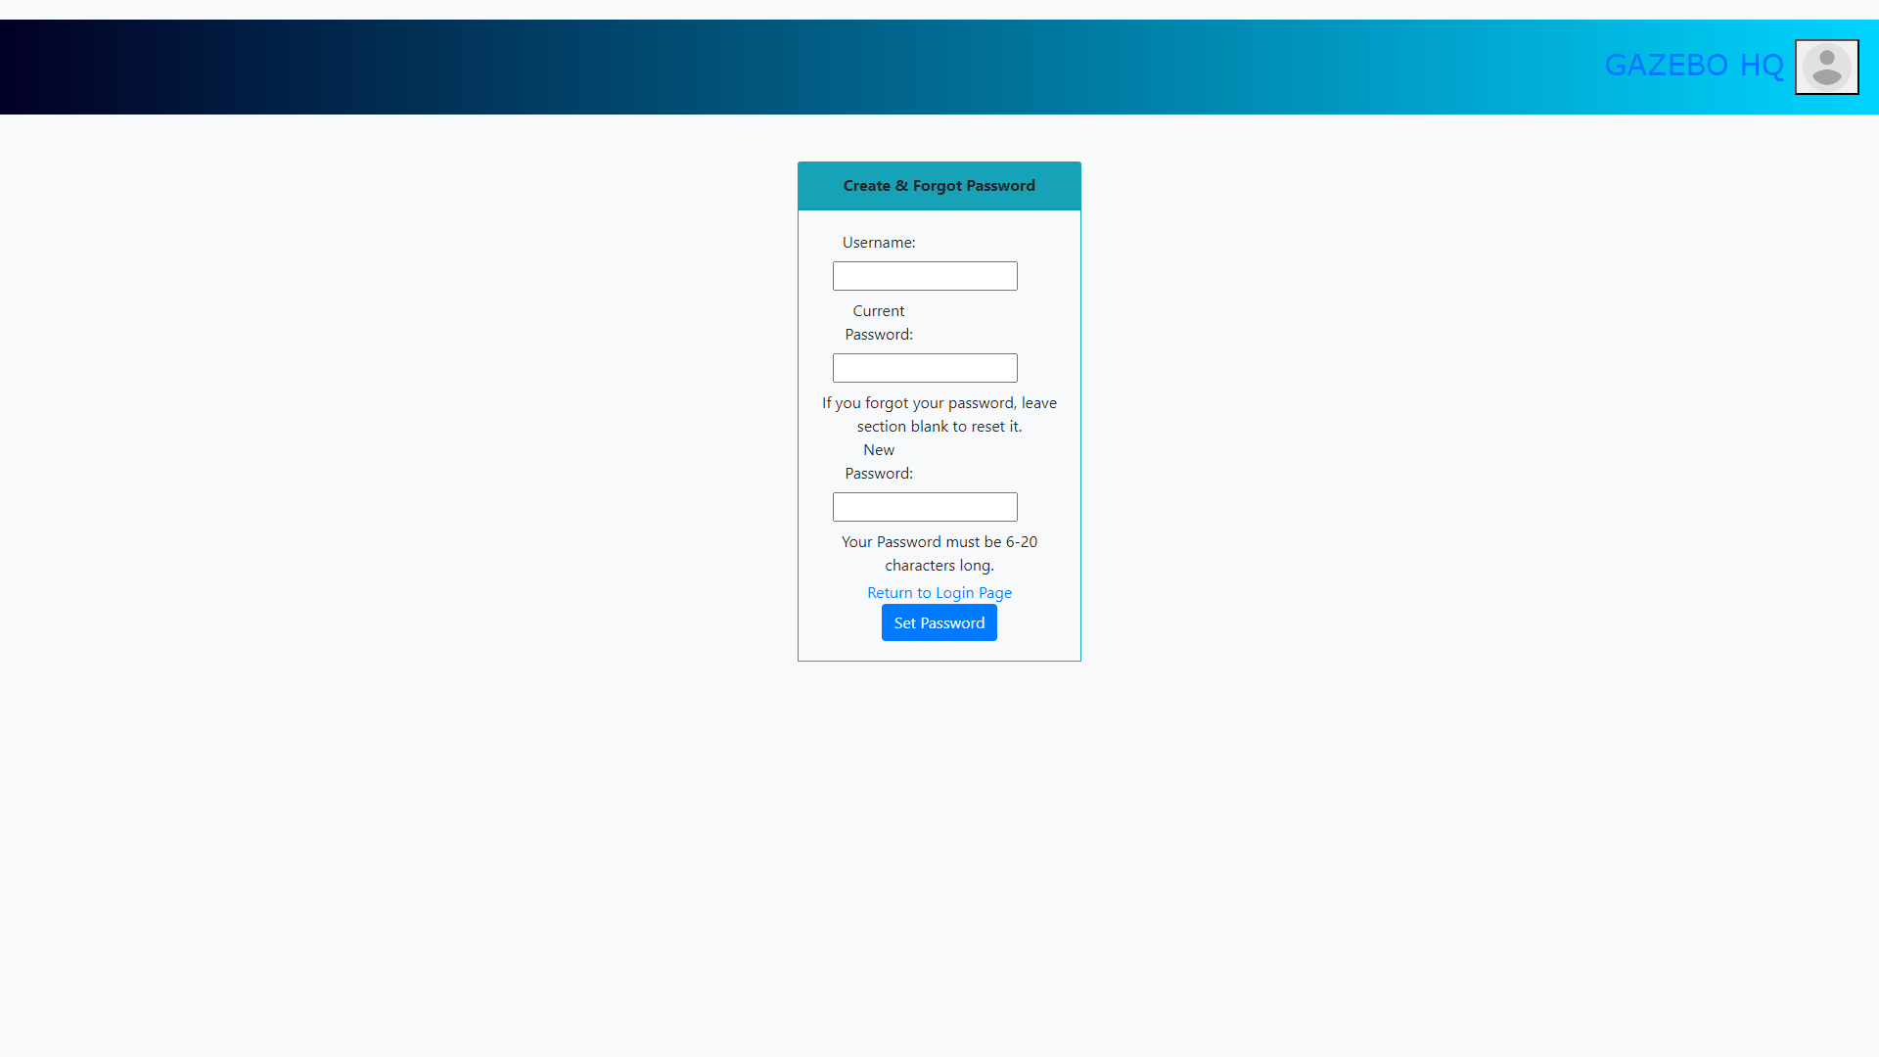

## Figure 3. Forgot & Create Password Page

* On the Create & Forgot Password page, users will be able to reset their password if they forgot it
* Or if they are creating a password after they had their user data imported
* If the user is unable to remember their password or they are creating a new one for a account, they would leave the the “Current Password” textbox empty
* This also allows the user to return to the Login page after they have set their password

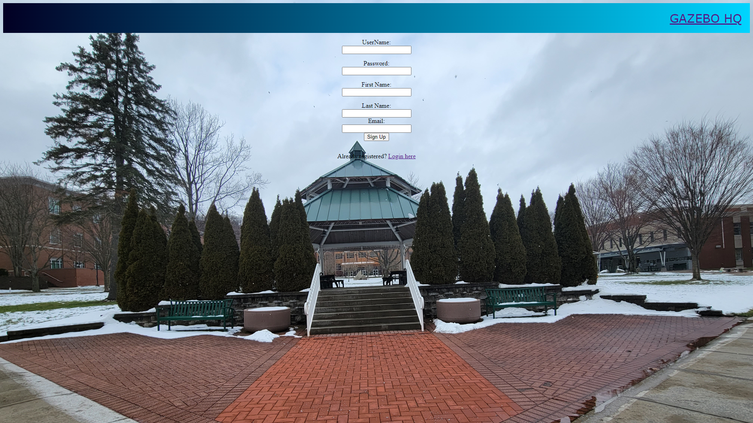

## Figure 4. Registration Page

* Upon reaching the registration page the user will be prompted to enter an username, password, first, and last name
* Once entered the user will select the “sign up” button or if they mistakenly clicked registration they may click “Login here” if they already have an account

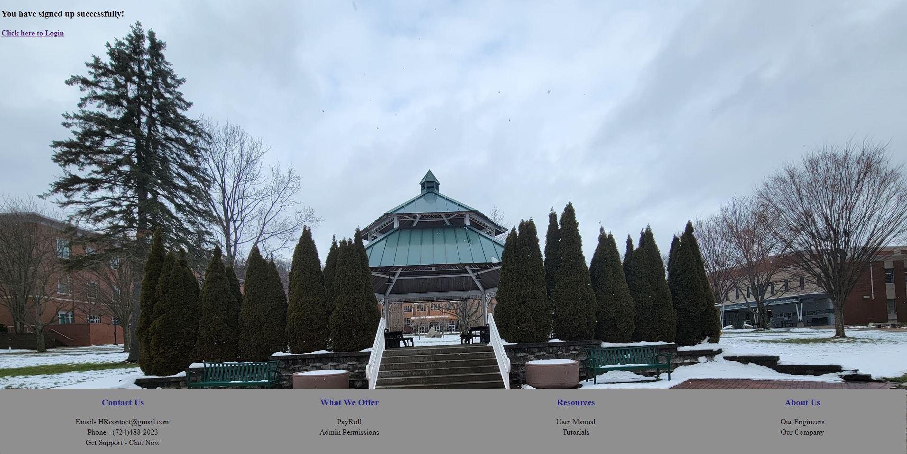

## Figure 5. Registration Successful Page

* Once clicking “sign up” users will reach a screen prompting them  
  to log into the system



## Figure 6. Login Successful Page

* You will receive this page, once you have login successful, if not you will be returned to the login page to re-enter your information

## Figure 7. User’s Dashboard

* Once logged in, users will be sent to the dashboard. On this page users can see what today’s date is and how many hours they have worked this pay period month
* If users hover their mouse over the menu button. A dropdown menu will appear showing users their different options within the application
* If users hover their mouse over the top right avatar icon they will see the “Sign Out” option and a option to go to “Settings”

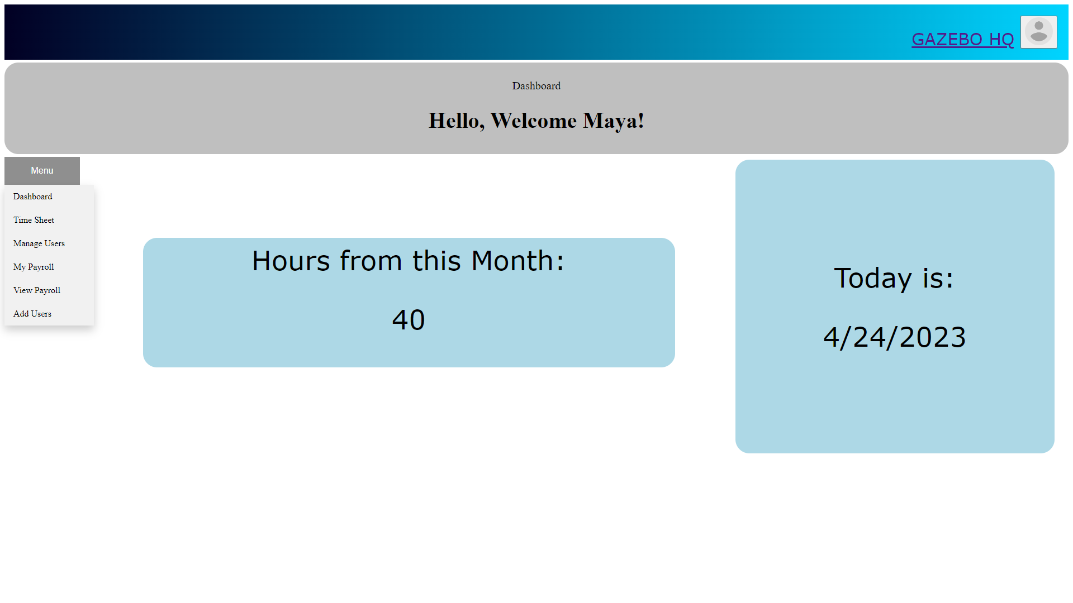

## Figure 8. Navigation Drop-Down

* Hovering over the Menu button will allow the user to travel to one of the following locations
* Additionally thanks to security authentication, certain pages are only accessible based upon the user’s login role
* Below explains what each page is capable of

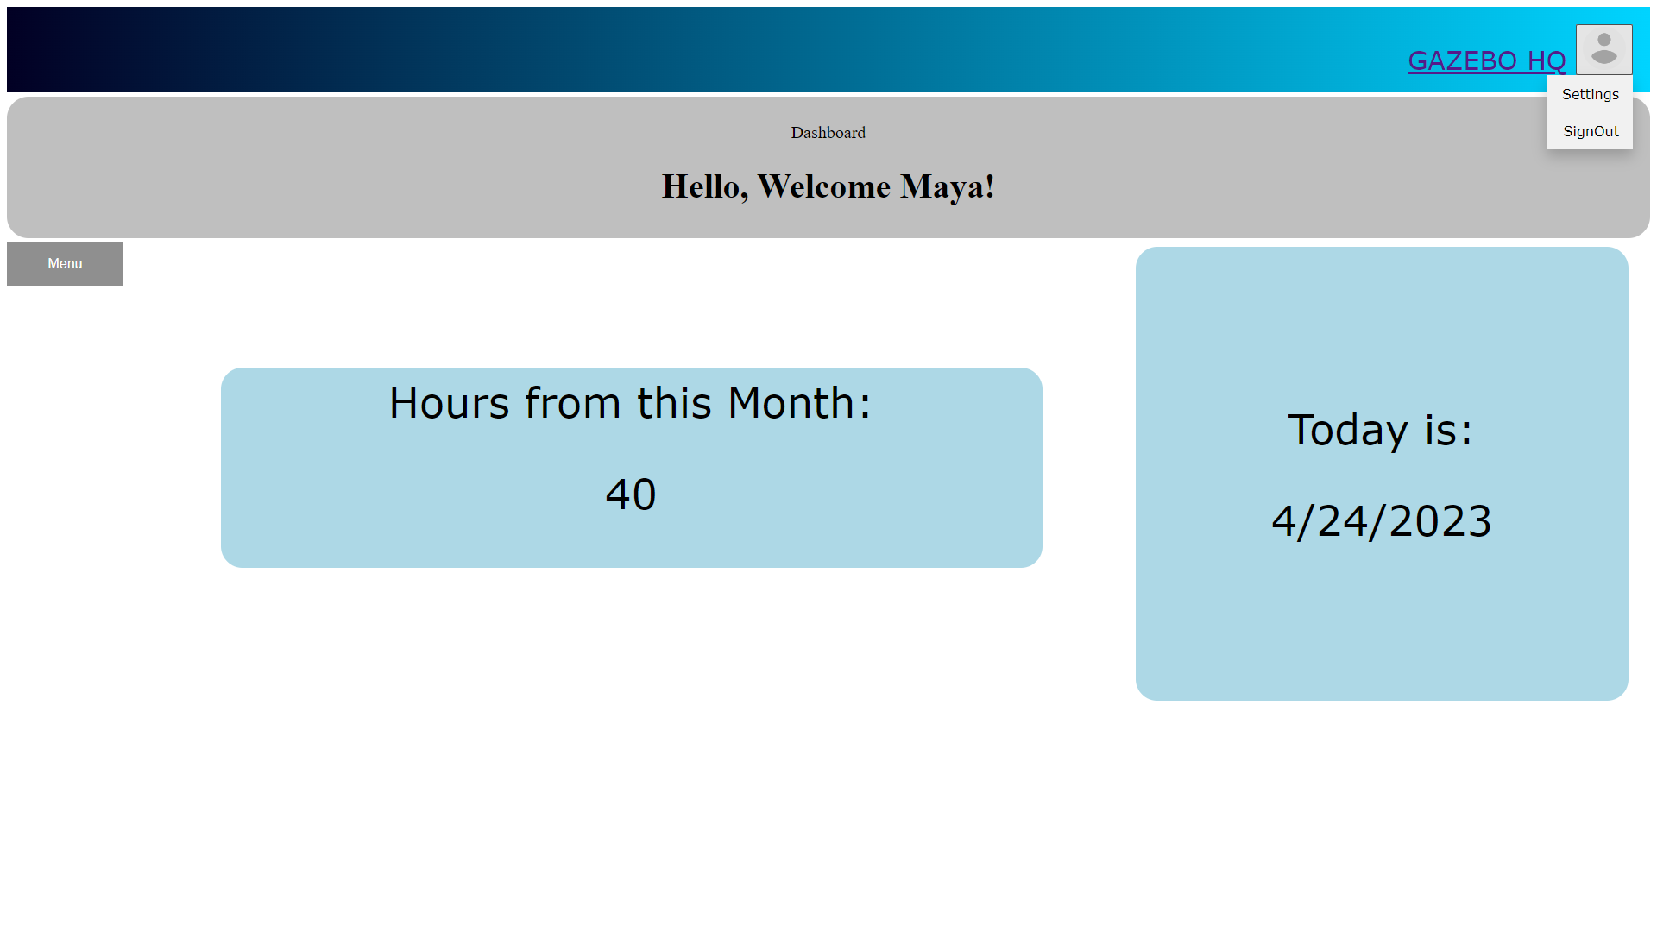

## Figure 9. Location of Settings & SignOut

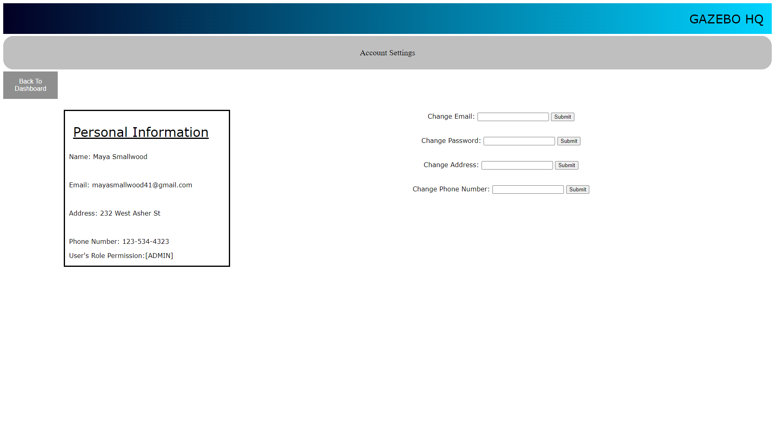

## Figure 10. Account Settings

* Here the user can see their personal information that is stored in the database
* Additionally the user can also set or change that following information

## Figure 11. Submit Timesheet

* Here Users can download a blank timesheet, in the form of a Microsoft excel .xlsx file and upload it to the MySQL database system to store and to populate the PayRoll pages

## Figure 12. Manage Users-Admin Access

* This page is only accessible through the Admin Role, here Admin users can view the list of users stored in the database
* They also have the ability to edit those’s user’s Role

## Figure 13. Role Edit-Admin Access

* Here Admin can enter in a user’s username and select what role they will now have
* Note: Every new user that registrations will automatically get the User Role permissions

## Figure 14. PayRoll-User Access

* This page is accessible by both User and Admin Permissions
* This will display a user’s personal information based upon the pay period, month pay, and employee information

## Figure 15. PayRoll-Admin Access

* This page is only accessible by Admin users
* Here will display all users, including themselves with an overview of all page wages, hours worked, and their total monthly pay

## Figure 16. Add Users-Admin Access

* Here Admin’s can import a excel file with a bulk list of creating new users
* Additionally if the password field is filled in, the system will auto encrypted the password allowing those new users to automatically be allowed to login

## Figure 17. SignOut Page

* Once the user selects “Sign Out” they will receive this page stating they have successfully done so